Microsoft Agent Framework based FastAPI RAG Service - Company Policy

This folder now runs a FastAPI-based RAG service over company_policy.md.

Changes on existing code
- Converted the previous CLI script into a FastAPI app.
- Added startup ingestion of the policy file into ChromaDB.
- Added an AG-UI SSE endpoint for chat clients plus a JSON chat fallback endpoint.
- Switched the policy file path to a relative path so it works locally and in containers.

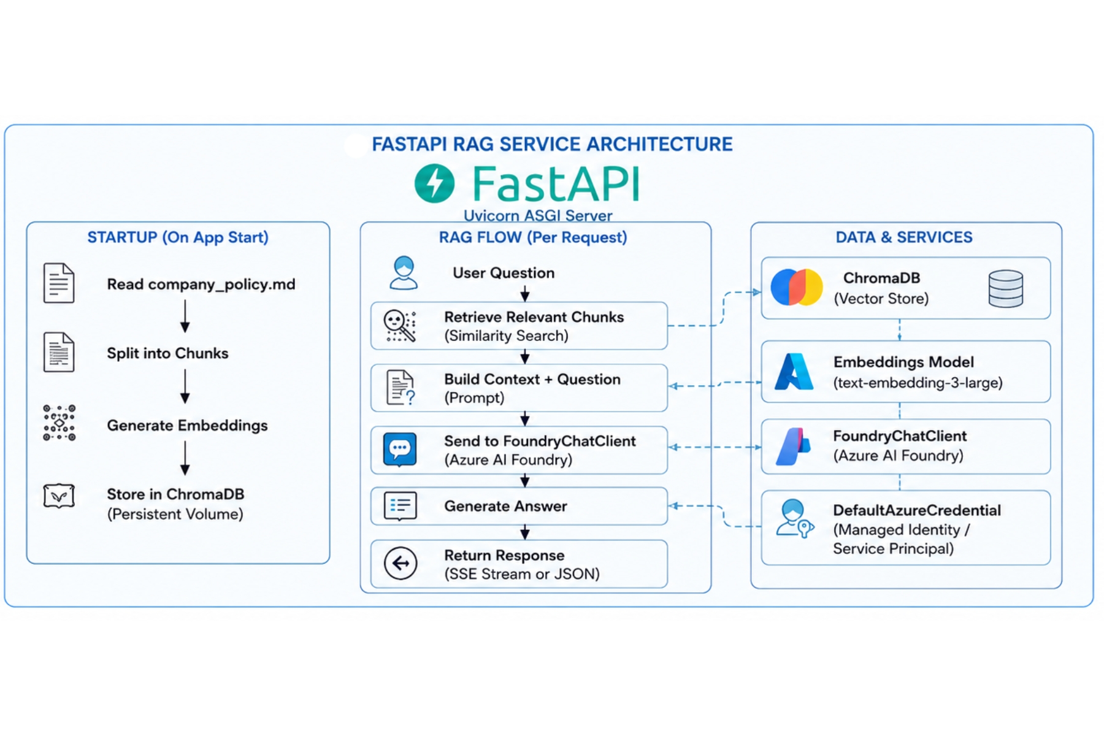

Requirements
Install dependencies:
pip install -r requirements.txt

Run Locally
From this folder:
python maf-rag.py
Alternative:
uvicorn --app-dir . maf-rag:app --host 0.0.0.0 --port 8000 --reload

API Endpoints

Health
- Method: GET
- URL: /health
- Response:
{
"status": "ok"
}

Chat (AG-UI)
- Method: POST
- URL: /chat
- Protocol: Server-Sent Events for AGUIChatClient.

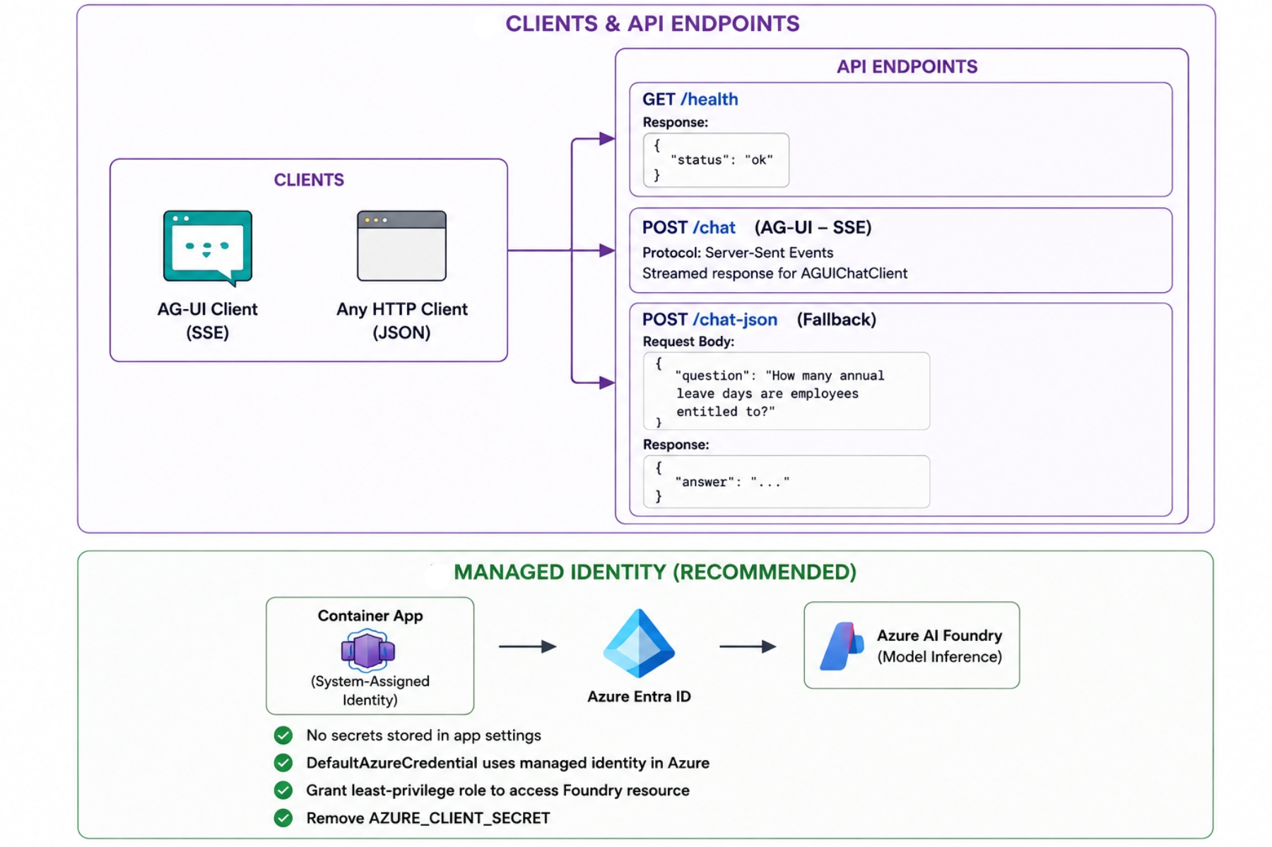

Chat (JSON fallback)
- Method: POST
- URL: /chat-json
- Body:
{
"question": "How many annual leave days are employees entitled to?"
}
- Response:
{
"answer": "..."
}

Environment
The app uses FoundryChatClient with DefaultAzureCredential. Set the same Azure/Foundry environment variables you use today for local execution.
For the sample client in this folder, set AGUI_SERVER_URL to http://127.0.0.1:8000/chat.

Container Notes
This FastAPI layout is container-ready. This repo includes Dockerfile, .dockerignore, and docker-compose.yml so you can run:
docker build -t maf-rag-fastapi .
docker run -p 8000:8000 maf-rag-fastapi

Docker Files Created (3 Files)
- Dockerfile Builds the FastAPI image using Python 3.11-slim, installs dependencies from requirements.txt, copies app code, and starts Uvicorn on port 8000.
- .dockerignore Excludes local-only and sensitive files from image build context (for example .venv, .env, logs, and git metadata) to keep images smaller and safer.
- docker-compose.yml Defines one service (api) that builds from the local Dockerfile, loads env vars from .env, and maps port 8000:8000 for local container runs.

Run As A Docker Container
Build and run:
docker build -t maf-rag-fastapi .
docker run --env-file .env -p 8000:8000 maf-rag-fastapi
Test:
curl http://127.0.0.1:8000/health
Optional with Docker Compose:
docker compose up --build

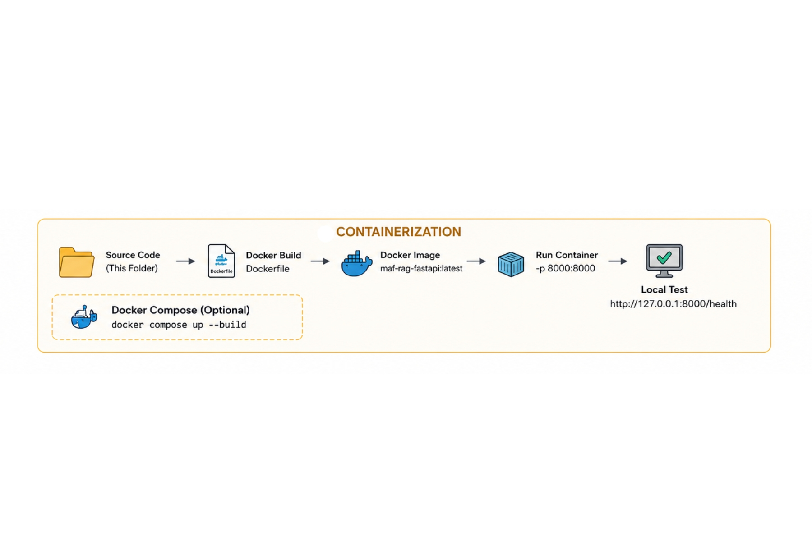

Deploy To Azure Container Apps
For a dedicated, production-friendly, step-by-step deployment runbook, see:
DEPLOY_CONTAINER_APP.pdf
Prerequisites:
- Azure CLI logged in (az login)
- Docker installed
- Resource group and Container Apps environment in your subscription
Example end-to-end commands:
# 1) Variables
$RESOURCE_GROUP = "rg-maf-rag"
$LOCATION = "canadacentral"
$ACR_NAME = "mafragacr"
$ACA_ENV = "mafrag-env"
$APP_NAME = "maf-rag-api"
$IMAGE = "$ACR_NAME.azurecr.io/maf-rag-fastapi:latest"
# 2) Create infra (one-time)
az group create --name $RESOURCE_GROUP --location $LOCATION
az acr create --name $ACR_NAME --resource-group $RESOURCE_GROUP --sku Basic
az containerapp env create --name $ACA_ENV --resource-group $RESOURCE_GROUP --location $LOCATION
# 3) Build image in ACR
az acr build --registry $ACR_NAME --image maf-rag-fastapi:latest .
# 4) Deploy Container App
az containerapp create `
--name $APP_NAME `
--resource-group $RESOURCE_GROUP `
--environment $ACA_ENV `
--image $IMAGE `
--target-port 8000 `
--ingress external `
--registry-server "$ACR_NAME.azurecr.io" `
--query properties.configuration.ingress.fqdn
Set runtime environment variables (replace values appropriately):
az containerapp update `
--name $APP_NAME `
--resource-group $RESOURCE_GROUP `
--set-env-vars `
FOUNDRY_MODEL="grok-4.3" `
FOUNDRY_PROJECT_ENDPOINT="https://obs-test-resource-resource.services.ai.azure.com/api/projects/obs-test-resource" `
AZURE_TENANT_ID="<tenant-id>" `
AZURE_CLIENT_ID="<app-client-id>" `
AZURE_CLIENT_SECRET="<app-client-secret>"

Managed Identity (Recommended For Azure)


Instead of storing AZURE_CLIENT_SECRET, use a system-assigned managed identity on the Container App.
- Enable managed identity on your app:
az containerapp identity assign `
--name $APP_NAME `
--resource-group $RESOURCE_GROUP `
--system-assigned
- Grant that identity permission to call your Foundry/AI resource (least privilege role for model inference in your environment).
- Remove secret-based auth vars from your app settings:
az containerapp update `
--name $APP_NAME `
--resource-group $RESOURCE_GROUP `
--remove-env-vars AZURE_CLIENT_SECRET
- Keep only non-secret runtime vars:
az containerapp update `
--name $APP_NAME `
--resource-group $RESOURCE_GROUP `
--set-env-vars `
FOUNDRY_MODEL="grok-4.3" `
FOUNDRY_PROJECT_ENDPOINT="https://obs-test-resource-resource.services.ai.azure.com/api/projects/obs-test-resource"
Because this app uses DefaultAzureCredential, it will automatically use the managed identity inside Azure Container Apps.
Then get the app URL:
az containerapp show --name $APP_NAME --resource-group $RESOURCE_GROUP --query properties.configuration.ingress.fqdn -o tsv
For AG-UI clients, set AGUI_SERVER_URL to:
https://<your-container-app-fqdn>/chat

